Galal Chamma

Sprint Day 2

**Homepage Listing and features:**

Description:

The home page will introduce the user to a list of genres of movies and tv shows to click on to further explore content in that area. This will be the first page that the user sees on our CheckFlix website.

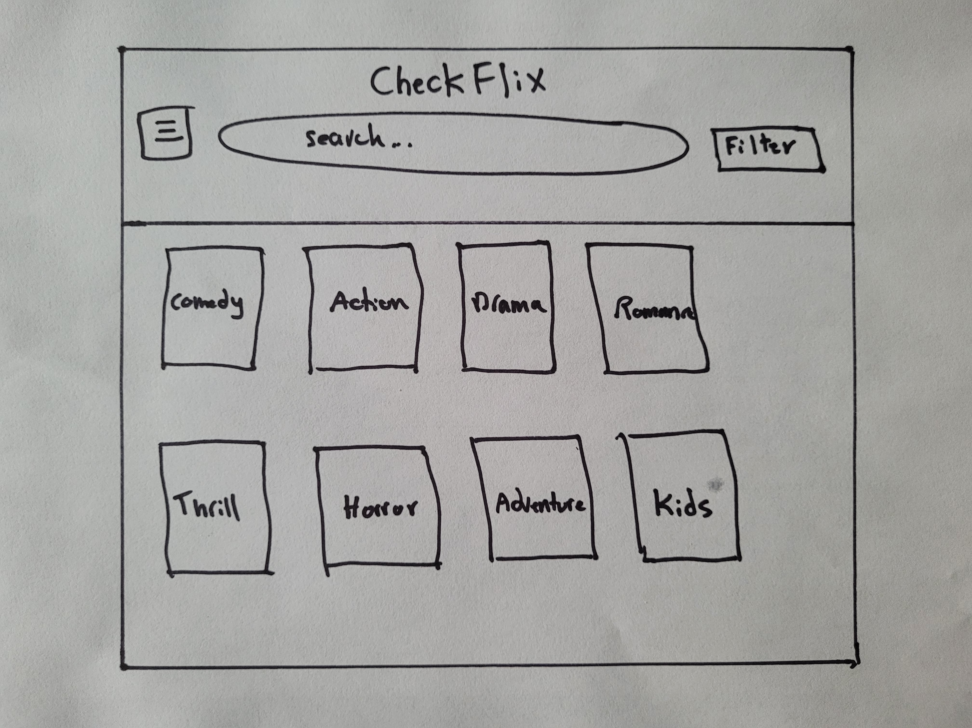

Notes:

* The genres listed will be:

Comedy, Action, Drama, Romance, Thriller, Horror, Adventure and Kids.

* Search bar at the top
* A filter button can be seen on the top right for the user to filter the movies based on his/her wishes
* The Logo can be seen on the top center
* Top left button with multiple lines drawn on it will lead the user to a menu to see what other features the website can offer.

**Search feature**

Description:

There is a search bar up top of the page for the user to be able to search for a specific movie or show by typing in the name of the its title or the director’s name.

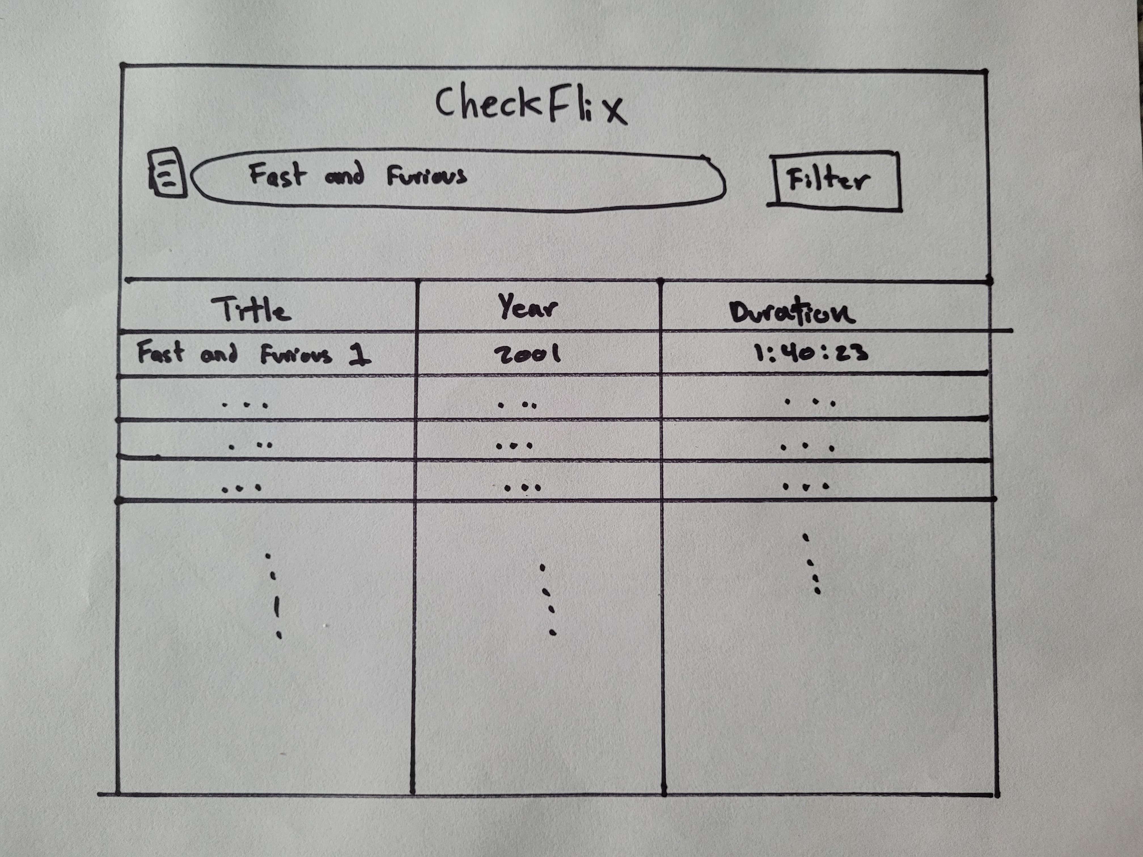

Notes:

* A list of titles will appear in a table-like window, where movies or shows that have a similar title to what was searched or have a director with the name of what was searched for, would be listed. I
* The columns or attributes for each entity would be title name, year released, and duration.
* The user can further click on a title name to see more detailed information about that specific title.

**Filter feature**

Description:

The filter feature allows the user to filter the list of movies and shows based on specific elements, such as: Maturity rating, Year released, duration, country released in, main language, and category.

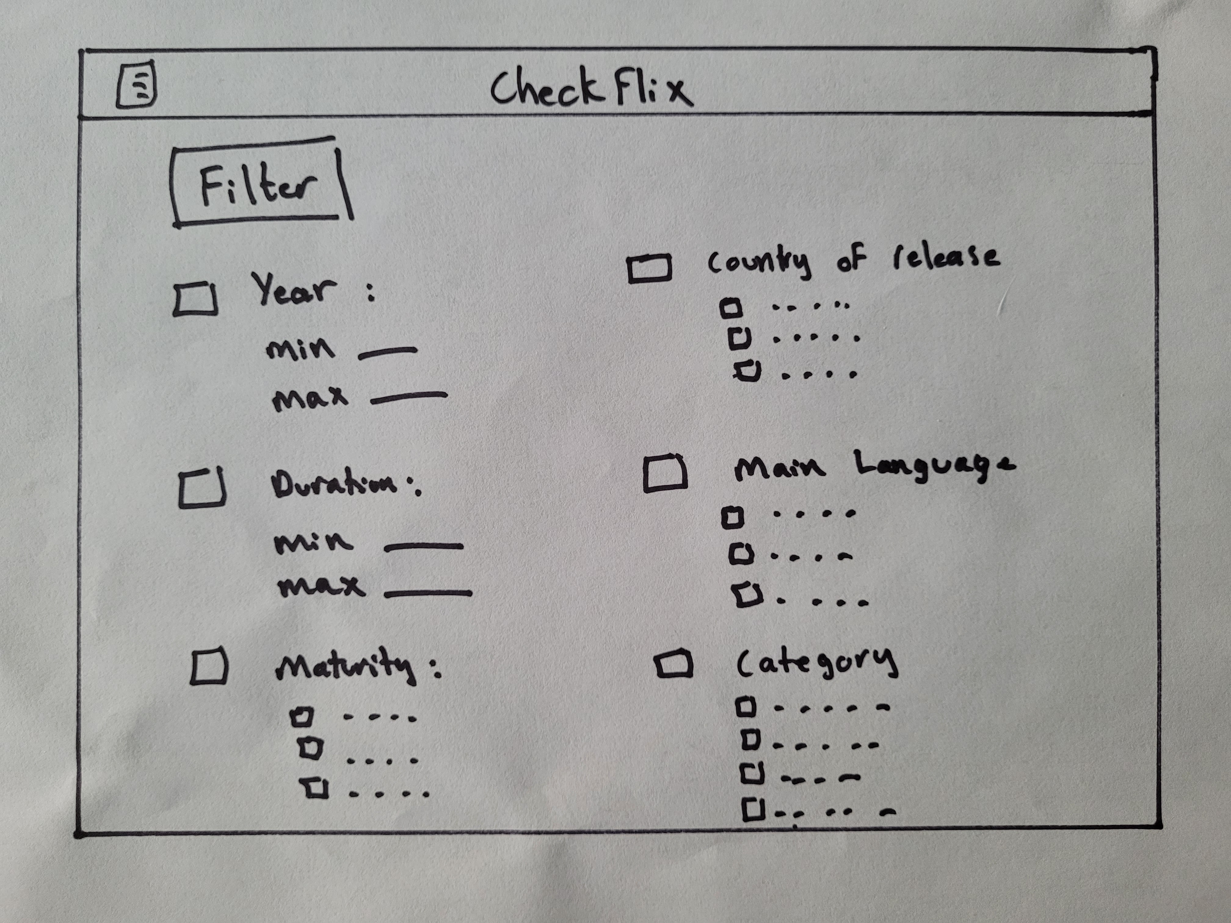

Notes:

A checkbox will be implemented to pick a specific element to choose from and then the user can:

* enter a min/max value for elements that accept integer values such as year released and duration
* Choose further sub-checkboxes for categories that don’t include integers, such as maturity, country of release, main language, and category, and type (movie or show).

These choices made by the user will be saved and not change upon the use of the search bar. They will filter movies and shows together with the search bar to give the user the best fitting title list.